**Public attitudes toward immigration in Canada**

Mehdi Mohamadian

Final Project Report

Professor

Firas Moosvi

Data 501

December 7, 2020

**Abstract**

Factors affecting anti-immigration attitudes have been investigated extensively. Research focusing on attitudes of Canadians , however, is very limited. In this paper, we use data from Canadian Election Studies (CES) in 2019 in order to explore the importance of socio-demographic as well as political affliations on shaping public opinion toward immigration. We found that Labour Market Competition Theory can weakly explain the attitudes of Canadians. We also confirm the fact that those who suppor the left wing parties are pro-immigration than supporters of other parties.

1. Introduction

Canada has a reputation over the last decades as one of the most welcoming countries for immigrants. In a recent plan announced by the government, Canada is going to accept more than one and a half million immigrants in the next three years. This inflow of immigrants has the potential to reshape the political arena of Canada. The recent evidence is the emergence of the People party in the 2019 election of Canada (Canada.ca). The party sees immigration as an issue because it changes “the cultural character and social fabric of our [Canada] country” (People Party’s official website). Although the People Party only gained around 300,000 votes in the recent election, it alarms the transformation of public discourse over immigration. Therefore, there should be a closer look at the attitude of Canadians toward immigration, the topic of this study.

The study of public opinion toward immigration in Canada is limited. Using Canadian Election Studies data in 2002, Fortin et al. (2004) found the importance of the level of education, employment status on shaping Canadians opinions toward immigration. Based on their findings, employed Canadians and people with higher education are more pro-immigration than others (Fortin and Loewen 2004). Harell et al. (2017) compared the opinion of Canadians and people living in the US. They found that Canadians relatively are more welcoming toward immigration but “this is not to say prejudicial outgroup attitudes do not exist in Canada” (Harell et al. 2012). they showed that both countries have more positive opinions toward educated and higher-skilled immigrants compared to low-skilled immigrants.

The goal of this study is to explore the importance of socio-demographic factors in shaping attitudes toward immigration in Canada. The second question that this article tries to answer is whether Canadians attitudes toward immigration are shaped by economic or cultural factors. In the last part, the article analyzes the importance of party support in shaping Canadians’ public opinion toward immigration. Accordingly, in the next section, the theories of public opinion toward immigration are presented. In section 3, we will describe the data and methodology. Section 4 presents empirical results and in section 5 we will conclude the paper.

**2. Literature review and hypothesis**

Various theories have been attempting to explain public attitudes toward immigration. However, it can be divided into three main categories: Political economy theories and Social-psychology theories and Group Threat theory. Political economy theories focus on material self-interest in which public opinion is formed through two channels of labor market competition and taxes.

According to the labor market competition theory, the source of opposition toward immigration depends on the skill distribution of both immigrants and native people. The model explains that the influx of low-skilled immigrants to a country decreases the wage of low-skilled people and raises the wage of high skill immigrants.  Therefore, natives predict the skill level of immigrants in order to form their attitude toward immigration. Although, there are findings related to low-skilled native people are more against immigration (Scheve and Slaughter 2001), this model fails to explain why high skilled native people support immigrants with the same level of skills (Hainmueller and Hiscox 2007). Canada has a unique policy toward immigration since it has been accepting mostly skilled immigrants. In its 2021 immigration plan, Canada expects to accept 401000 immigrants of which more than 50 percent are skilled workers.

The other channel that public opinion might be affected by the political economy theory is taxes. Based on the fact that low-skilled people are the ones receiving more benefits than paying taxes, the influx of unskilled immigrants puts more pressure on government budgets instigating either an increase in tax rates or a reduction in per capita transfer for public spending (Hainmueller and Hopkins 2014). Therefore, an increase in low-skilled immigrants makes high-skilled natives more concerned about their economic situation. However, some findings argue that the fiscal burden of immigration, similar to the labor market model, only impacts low-skilled natives and alarms them about immigration-induced government spending hikes (Hanson, Scheve, and Slaughter 2005). To explore the role of economic factors on public attitude following hypotheses will be examined:

Hypothesis 1: *Those who are in economic distress are more likely to be against immigration*

Hypothesis 2: *Those who are exposed to more competition with immigrants in the labor market are more against Immigration*.

TO understand the importance of cultural factors on attitude toward immigration, scholars use various theories including Cultural Marginality, Cultural Values and Cultural threat (Rustenbach 2010; Gravelle 2018; Hainmueller and Hopkins 2014; Hainmueller and Hiscox 2007). However, they are mainly originated from two major groups correlated with prejudice against a group. "Some of these models emphasize individual-level mechanisms; others focus on group-level causes where hostility towards immigrants is driven by perceived threats against the group resources or status, rather than the individual herself" (Javdani, 2020, 7).

In social psychological approaches, scholars generally apply statistical models to understand the importance of demographic and individual factors including education, gender and religion, to analyze attitudes toward immigration. Therefore, individual-level factors shaping racial prejudice originates from "individual emotional and/or cognitive processes that are beyond completely conscious control" (Quillian, 1995, 587). Accordingly, Social-psychological theory points out that attitudes toward immigration are shaped by complicated processes during one's childhood or "an expression of stereotypical beliefs resulting from cognitive limitations and distortions in attributions" (Quillian 1995, 587). Based on the literature, the following hypothesis will be examined:

Hypothesis 3: *Religion is an important factor in shaping attitude toward immigration*

One important factor that may shape public opinion towards immigration in Canada is the province of living. Reginal cleavage in Canada has been vastly reported by scholars. One area that this regional cleavage shows itself is the voting behavior of Canadians. Gidengil et al (1999) show that even after controlling for salient socio-economic factors people who live in Ontario are more likely to vote for Liberals (Gidengil et al. 1999). White and Nevitte (2013) showed that people who live in British Columbia are more pro-immigration than people living in Ontorio (White and Nevitte 2013). Therefore, this article will test the following hypothesis:

Hypothesis 4: *There are opinion cleavages among people living in different provinces of Canada.*

The other important theory related to psychological factors shaping attitudes toward immigration is the Group Threat theory. According to this approach, "a sense of group position grows out of a history of unequal power relations between groups and prejudice is a defensive reaction against explicit or (usually) implicit challenges to the dominant group's exclusive claim to privileges" (Quillian 1995, 588). ).  Realistic conflict theory which is one of the branches of Group Threat theory broadens the notion of self-interest from a particular individual to the dominant group of society (natives) to explain that harms to one individual native could be supposed as detrimental to all people of that society (Sidanius and Pratto 1999). For example, even if immigrants are less likely to commit crimes in society but the belief that immigrants are criminal forms the attitudes of native people. Therefore, we may expect that:

Hypothesis 5: Those who consider themselves native are more against immigration.

Hypothesis 6: The opposition to immigration increases if people say that immigrants increase the crime rate in society.

The other important factor that may create inner and outer groups is the political support of a party. In this case, a party “serves as the group toward which individual may develop identification, positive or negative, of some degree of intensity”(Campbell et al., 1960, 122). Therefore, we expect that there is a difference between supporters of different parties and their attitudes toward immigration. For example, some scholars find that the Liberal party of Canada is perceived as the best party in handling the immigration issue. This perception is shaped since it was a Liberal prime minister, Trudeau, who adopted the policy of multiculturalism in 1971, and again it was him to introduce the Charter of Rights in 1981 (Bilodeau and Kanji 2010). Based on this line of reason, the following hypothesis will be examined:

Hypothesis 7: those who voted for the Liberal party are more pro-immigration than other parties.

**4.Data and methodology**

This article uses Canadian Election Studies’ (CES) data in 2019 to explore public opinion toward immigration in Canada. CES is a public institution in which its goal is to collect a rich source of data on the political behaviors of Canadians and their opinion toward different issues. The 2019 survey was conducted in all provinces of Canada in two waves of before and after the election. Overall, 37,822 people living in Canada participated in the campaign period survey in which 10340 of them are contacted for the post-election survey. In this analysis, I use both post-election and pre-election surveys. After coding and removing the missed value 3574 observations (Table 1) remained for answering the questions raised by this article.

The independent variable measuring the opinion of Canadians toward immigration is extracted from the following question: Do you this Canada should admit more, about the same or fewer immigrants. Fewer immigrants is coded as 1, About the same as 2 and More immigrants as 3.

Factors potentially shaping attitude toward immigration are as follow: (1) *Education*: the CES asks participants of their highest level of education. The options are from no-schooling to professional degree and doctorate. (2) *Province*: it is the province of living of respondence (3) *Native*: this variable is extracted from the place of born of Canadian and consists of two categories of Canada and Immigrant. (4) *Employment status*: this is a categorical variable measuring the employment status of participants. (5)*Age*: it is a continuous variable measuring the age of respondents (6) *Financial situation*: the CES asks respondents if over the last year their financial situation got better (1), stayed about the same (2) or got worse (3). (7) *Vote choice*: this variable is computed based on two questions. The first question asks Canadians if they voted in the election and the second question asks which party they voted for in the 2019 election. Accordingly, the variable has 7 categories of Liberal Party, Conservative Party, NDP, Bloc Quebecois, Green Party, People Party and not voted. (8) *Labor market perception:* this is an ordinal variable measuring the perception of Canadians about immigrants. It is coded according to the question asking how much they agree that immigrants take jobs away from other Canadians. The options are from Strongly agree (1) to strongly disagree (5). (9) *Cultural Threat Perception:* this is an ordinal variable measuring if respondents see immigrants as a cultural issue. The variable is computed from the question asking how much they agree minorities should adopt the customs and traditions of Canada. The options are from strongly agree (1) to strongly disagree (5). (10*) Crime threat Perception:* this is an ordinal variable measuring if respondents see immigrants as a crime threat. The variable is computed from the question asking how much the agree immigrants increase crime rates in Canada. The options are from strongly agree (1) to strongly disagree (5).

In order the analyze the attitude of Canadians toward immigration first the article explore the opinion of different socio-demographic groups toward immigration and then run an OLS regression to have a closer look at these factors when other factors are controlled. Then, I will add the Vote Choice variable in order to analyze the importance of party support. In the next regression, I will explore how these attitudes are shaped in Canada by adding the Labor Market Perception, Cultural Threat Perception, and Crime Threat Perception to the previous model.

**5. Empirical Results**

This study aims to analyze the attitude of different socio-demographic variables toward immigration. Figures 1 to 5 show the attitudes of different socio-demographic variables toward immigration. In Figure 5, it is clear that as people become more educated they become more pro-immigration. Only 22 percent percept of people with a PhD or professional degree said Canada should admit fewer immigrants compared to 55 percent of people with completed elementary school. The attitude of different employment statuses toward immigration (Figure 1) is complicated and it is not as clear as the education levels. The most striking category is the Caring for family in which 55 percent of them believe that the level of immigration in Canada should be decreased. 51 percent of unemployed people also believe that Canada has to admit fewer immigrants. This result may suggest the importance of Labor Market theory in Canada. As figure 3 shows there is a difference between the attitude of Canadian-born people and immigrants. 38.27 percent of Canadian-born believe that Canada should admit fewer immigrants compared to 30 percent of immigrants. Figure 5 shows the importance of the province of living on the attitude of people. Surprisingly, 53.75 percent of people living in Saskatchewan believe that Canada should admit fewer immigrants while the number in Nova Scotia is only 24 percent. One may argue that these graphs do not show the importance of each variable because for example there are more immigrants in Ontario compared to Alberta and that is the reason for the different attitudes of the two provinces. To explore in more detail, the article runs OLS to understand the importance of different variables.

In Model 1 of Table 2, the OLS regression estimates the impacts of different socio-demographic variables on immigration attitudes. For the Education variable, the omitted category is Atheists. The coefficients of Hindus, Anglican, Baptist, Catholics, Orthodox, Protestants are significant and negative implying that these groups of people have more negative attitudes toward immigration than the Atheists after controlling for other socio-demographic variables. It is interesting that the variable for Hindus is strongly significant as this group is a minority in Canada and it is expected to be more welcoming toward immigration. The omitted category for Employment status variable is those working full-time. The result suggests that retired people in Canada have a more positive attitude toward immigration than the reference group showing that tax burden theory cannot explain the Canadians’ attitude as retired are those people because these people depend on the pensions that a part of it coming from taxed and the government’s budget. The categories of unemployment and caring for a family are also not significant which is surprising as it shows there are no differences between those who are in economic distress and those who are not.

Our regression analysis confirms the Gidengil et al. (1999) and White & Nevitte ( 2013) results that there are regional cleavages between the provinces of Canada, According to Figure 1, people living in British Columbia, Manitoba, New Brunswick, Ontario, New Foundland, Nova Scotia and Quebec have more positive attitude than Alberta. The only province that is more against immigration compared to Alberta is New Saskatchewan. This result suggests that differences between provinces cannot be explained by differences in socio-economic distribution of people. Rather, there is something rooted historically in these provinces which produces these regional cleavages. Accordingly, these findings are aligned with hypothesis 4.

The regression results also suggest that we must confirm hypothesis 5. After controlling for socio-demographic variables immigrants are more welcoming toward immigration than Canadian-born people. The most surprising result is for education. As we can see, the level of education does not have any significant impact on attitudes toward immigration.

In model 2 of Table 2, the Vote choice variable is added. The result confirms the argument that those who voted for the Liberal party are more pro-immigration than supporters of other parties. People who voted for the People Party and Conservatives also are more than any other voters are against immigration. This is true even after controlling for other variables. The only category which does not have a significant difference with the Liberal Party is the NDP. This is not surprising as it is a leftist party which the leader of it Jagmeet Singh is a minority.

In the last model, three Perception variables as well as Financial status are added to the model. These variables capture the source of opposition in Canada. The coefficients for all three variables are significant. It means one level of increase in the agreement that immigrants are cultural, economic and crime threats increase the probability of being against immigration. Accordingly, all three threats can explain the Canadians’ opposition to immigration. Furthermore, the Financial situation implies that those who said their financial situation got worse are more against immigration. Although the coefficients for Employment Status was not significant, the results of Model 3-Table 2 show we can weakly confirm that those who are in economic distress are more likely to be against immigration.

**6.Conclusion**

The goal of this study was to answer three questions. First, what are the attitude of different socio-demographic groups toward immigration? Second, what is the relationship between vote choices and Canadians’ opinion about immigration? Third, how the opposition toward immigration is shaped in Canada.

We found the importance of province of living on the attitude toward immigration. Among provinces in Canada, Saskatchewan and Alberta are more against immigration than any other provinces. The most welcoming province is also Nova Scotia, even after controlling for socioeconomic variables. This result confirms the fact that the differences between provinces in Canada do not come from the uneven socioeconomic distribution of Canadians. Rather, it is originated from the long history of introduced policies in the provinces.

We also found weak signs of Labour Market Competition theory in shaping the attitude of immigration. Based on this theory, natives are against immigration because they perceive a sense of competition with immigrants over scarce resources. This theory is confirmed by many scholars who study the public opinion toward immigration in Europe (Scheve and Slaughter 2001; Hainmueller and Hopkins 2014). The failure of this theory in Canada can be explained by the fact that this country has a very selective, skill-based immigration system. Therefore, those who have less education do not feel a sense of competition with immigrants in the labor market.

Our regression results confirm the importance of party support on forming attitudes toward immigration. Generally speaking, people who voted for left-wing parties (Liberal and NDP parties) are more pro-immigration than those supporting right-wing parties (Conservatives and People Parties). This result is agreement with other work that had recorded the importance of party affiliation in shaping attitudes toward immigration. Fortin and Loewen (2004) those who identify themselves as Liberal are more likely to request an increase in the level of immigration than those who identify with the Conservatives in Canada.

While there is a rich literature on public opinion toward immigration, more research is still required to unravel the complexity of Canadian attitudes toward immigration. More importantly, more study is needed to explain why some provinces are more pro-immigration than others. The other possible avenue of research is to examine the effect of immigration on shaping attitudes toward immigration. It would be interesting to see if provinces with the high immigration intake in their history are more against immigration than others or not. One of the limitations of this study is that it does not take into account the fact that as well as those three theories of Political Economy, Cultural Threat and Socio-psychology, media and news agencies may have significant roles in shaping public option.

**Figures and Tables**

Table

Summary statistics

|  |  |  |  |  |  |
| --- | --- | --- | --- | --- | --- |
| Variable | Number of Observation | Mean | Std error | Min | Max |
| Immigration attitude | 3574 | 3.8 | 1.07 | 1 | 3 |
| Age | 3574 | 54.7 | 15.5 | 18 | 99 |
| Labor Market Perception | 3574 | 2.38 | 1.28 | 1 | 5 |
| Cultural Threat Perception | 3574 | 3.89 | 1.07 | 1 | 5 |
| Crime Threat Perception | 3574 | 2.43 | 1.26 | 1 | 5 |
| Financial Situation | 3574 | 2.14 | 0.63 | 1 | 4 |

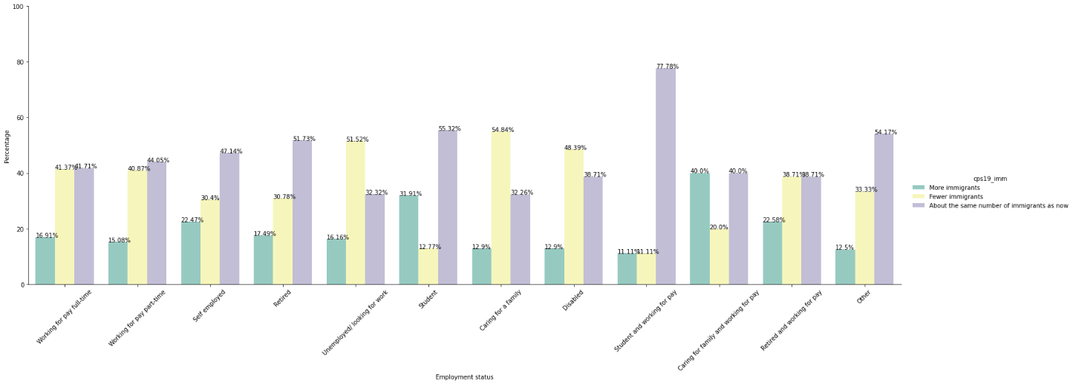

Figure :Attitude of different employment status toward immigration

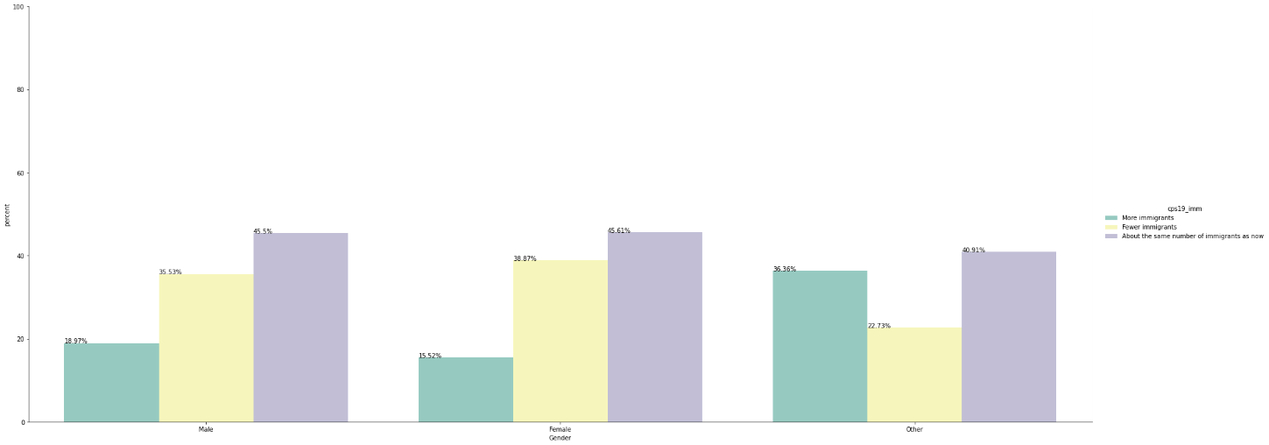

Figure : Attitude of different genders toward immigration

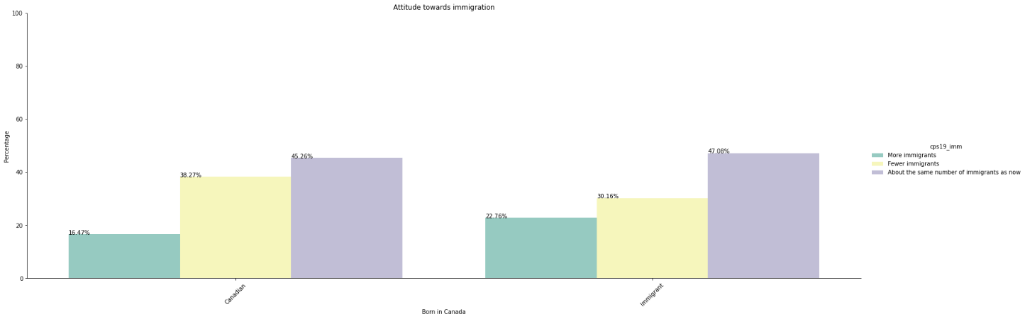

Figure :Attitude of natives and immigrants toward immigration

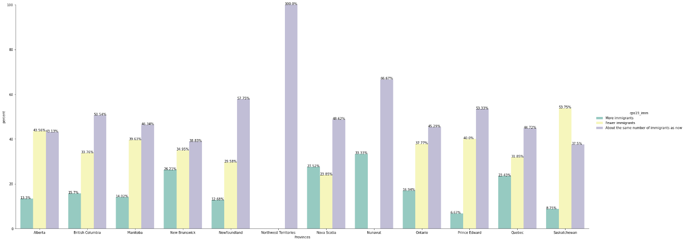

Figure :Attitude of different provinces toward immigration

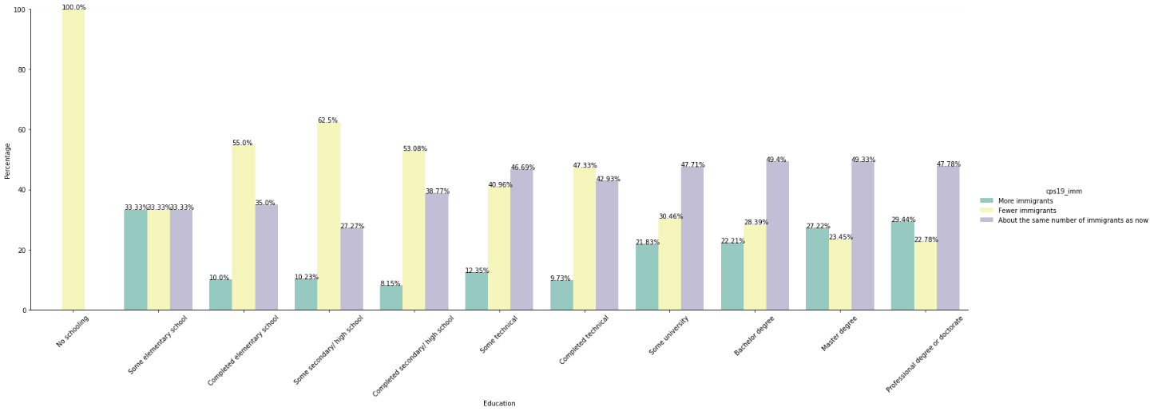

Figure :Attitude of different education levels toward immigration

Table : Regression Models

|  |  |  |  |  |  |  |
| --- | --- | --- | --- | --- | --- | --- |
|  | Model 1 | | Model 2 | | Model 3 | |
| Variables | Coeficient | SE | Coeficient | SE | Coeficient | SE |
| Religion | Reference Group= Atheists | | | | | |
| Agnostic | 0.07 | 1.42 | 0.06 | 1.21 | 0 | -0.08 |
| Buddhist | 0.07 | 0.51 | 0.1 | 0.8 | 0.15 | 1.39 |
| Hindu | -0.56*** | -3.16 | -0.4*** | -2.38 | -0.26 | -1.8 |
| Jewish | -0.08 | -0.9 | -0.02 | -0.24 | 0.01* | 0.22 |
| Muslim | 0.09 | 0.82 | -0.01 | -0.1 | 0.07 | 0.77 |
| Sikh | -0.11 | -0.6 | -0.13 | -0.77 | -0.09 | -0.64 |
| Anglican | -0.24*** | -4.64 | -0.21*** | -4.25 | -0.12*** | -2.86 |
| Baptist | -0.27*** | -3.7 | -0.11 | -1.63 | -0.04 | -0.62 |
| Catholic | -0.17*** | -5.44 | -0.12*** | -4.05 | -0.01 | -0.4 |
| Orthodox | -0.27*** | -2.86 | -0.17*** | -1.89 | -0.1 | -1.31 |
| Jehovahs Witness | 0.41 | 1.34 | 0.49 | 1.73 | 0.57*** | 2.34 |
| Lutheran | -0.19*** | -2.3 | -0.12*** | -1.48 | -0.02 | -0.35 |
| Church of Jesus | -0.24 | -1.2 | -0.04 | -0.19 | 0.03 | 0.19 |
| Pentecostal | -0.12 | -1.56 | 0.06 | 0.79 | 0.1 | 1.62 |
| Presbyterian | -0.19 | -2.27 | -0.1 | -1.24 | -0.04 | -0.67 |
| Protestant | -0.29*** | -5.23 | -0.19*** | -3.64 | -0.12*** | -2.66 |
| United Church of Canada | -0.15*** | -2.92 | -0.12*** | -2.45 | -0.08*** | -1.86 |
| Christian Reformed | -0.11 | -0.92 | 0.02 | 0.2 | 0.11 | 1.25 |
| Salvation Army | -0.48*** | -2.79 | -0.39*** | -2.4 | -0.18 | -1.28 |
| Mennonite | 0.06 | 0.36 | 0.15 | 0.93 | 0.14 | 1.09 |
| Employment Status | Reference Group= Working for pay (full-time) | | | | | |
| Working for pay part-time | 0.04 | 0.93 | 0 | 0.1 | 0.02 | 0.55 |
| T.Self employed | 0.18*** | 3.73 | 0.17*** | 3.63 | 0.09*** | 2.38 |
| Retired | 0.17*** | 4.78 | 0.15*** | 4.35 | 0.09*** | 3.19 |
| Unemployed/ looking for work | 0.01 | 0.08 | 0.05 | 0.68 | 0.11* | 1.87 |
| Student | 0.35*** | 3.41 | 0.29*** | 2.99 | 0.13 | 1.62 |
| Caring for a family | -0.1 | -1.17 | -0.05 | -0.54 | 0.05 | 0.72 |
| Disabled | 0.03 | 0.43 | -0.02 | -0.31 | 0.03 | 0.47 |
| Student and working for pay | 0.13 | 0.59 | 0.24 | 1.1 | 0.03 | 0.18 |
| Caring for family and working for pay | 0.34 | 1.12 | 0.23 | 0.81 | 0.15 | 0.62 |
| Retired and working for pay | 0.16 | 1.31 | 0.17 | 1.43 | 0.15 | 1.53 |
| Other | 0.06 | 0.46 | -0.01 | -0.09 | -0.03 | -0.28 |
| Provinces | Reference Group= Alberta | | | | | |
| British Columbia | 0.08** | 1.85 | -0.08** | -1.79 | -0.09*** | -2.61 |
| Manitoba | 0.08 | 1.29 | -0.03 | -0.59 | -0.09 | -1.89 |
| New Brunswick | 0.25*** | 3.35 | 0.1 | 1.46 | 0.06 | 0.93 |
| Newfoundland | 0.19*** | 2.19 | 0 | -0.04 | -0.07 | -1.06 |
| Northwest Territories | 0 | 0 | -0.29 | -0.45 | -0.11 | -0.2 |
| Nova Scotia | 0.35*** | 4.9 | 0.13*** | 1.85 | 0.05 | 0.86 |
| Nunavut | 0.39 | 1 | 0.01*** | 0.02 | -0.16 | -0.5 |
| Ontario | 0.08*** | 2.09 | -0.07 | -2.08 | -0.07*** | -2.19 |
| Prince Edward | -0.02 | -0.09 | -0.25 | -1.49 | -0.18 | -1.28 |
| Quebec | 0.2*** | 4.7 | 0.05*** | 1.06 | 0.04 | 0.91 |
| Saskatchewan | -0.09 | -1.52 | -0.12 | -2.04 | -0.08 | -1.64 |
| Gender | Reference Group= Male | | | | | |
| Female | -0.02 | -0.84 | -0.08 | -3.55 | -0.07*** | -3.82 |
| Other | 0.25* | 1.74 | 0.16 | 1.19 | 0.08 | 0.68 |
| Education Level | Reference Group= No schooling | | | | | |
| Some elementary school | 0.86 | 1.1 | 0.91 | 1.23 | 1.16 | 1.85 |
| Completed elementary school | 0.44 | 0.64 | 0.71 | 1.08 | 0.91 | 1.64 |
| Some secondary/ high school | 0.26 | 0.38 | 0.6 | 0.93 | 0.91 | 1.68 |
| Completed secondary/ high school | 0.38 | 0.56 | 0.66 | 1.03 | 0.92 | 1.7 |
| Some technical | 0.52 | 0.77 | 0.77 | 1.2 | 0.96 | 1.77 |
| Completed technical | 0.45 | 0.67 | 0.72 | 1.12 | 0.9 | 1.67 |
| Some university | 0.7 | 1.03 | 0.93 | 1.46 | 1.02** | 1.89 |
| Bachelor’s degree | 0.75 | 1.1 | 0.98 | 1.53 | 1.02* | 1.88 |
| Master’s degree | 0.81 | 1.2 | 1.03 | 1.61 | 1.06*** | 1.95 |
| Professional degree or doctorate | 0.85 | 1.26 | 1.07 | 1.67 | 1.07*** | 1.98 |
| Nativr | Reference group= Canadian-born | | | | | |
| Immigrant | 0.1*** | 2.84 | 0.09 | 2.78 | 0.06*** | 2.26 |
| Age | 0*** | 0.49 | 0 | 1.27 | 0 | 0.72 |
| Vote choice | Reference Group= Liberal Party | | | | | |
| Conservatives |  |  | -0.51*** | -18.51 | -0.22*** | -9.08 |
| NDP |  |  | -0.03 | -0.89 | -0.02 | -0.81 |
| Bloc Quebecous |  |  | -0.3*** | -5.21 | -0.13*** | -2.65 |
| Green Party |  |  | -0.09*** | -1.97 | -0.03 | -0.81 |
| People Party |  |  | -0.71*** | -7.97 | -0.32*** | -4.22 |
| Not voted |  |  | -0.23*** | -2.35 | -0.15*** | -1.86 |
| Perception Variables |  | | | | | |
| Crime Threat Perception |  |  |  |  | -0.08*** | -8.4 |
| Cultural Threat Perception |  |  |  |  | -0.11*** | -11.09 |
| Labor market perception |  |  |  |  | -0.17*** | -17.96 |
| Financial situation |  |  |  |  | -0.08*** | -5.25 |
| Intercept | 1.09 | 1.61 | 1.15* | 1.79 | 2.15*** | 3.95 |
| *** p<0.01, ** p<0.05, * p<0.1 | | | | | | |

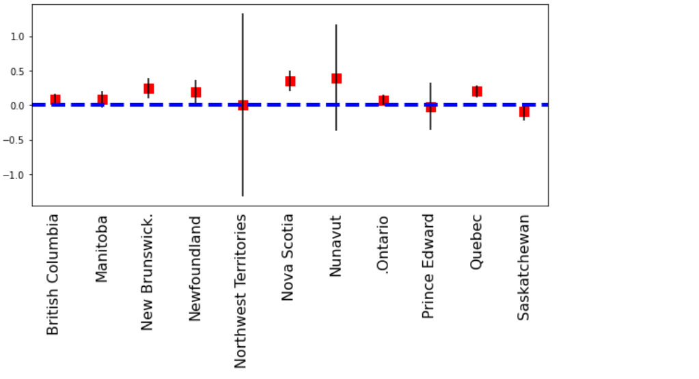

Figure : Province coefficient results of Model 1(Reference =Alberta)

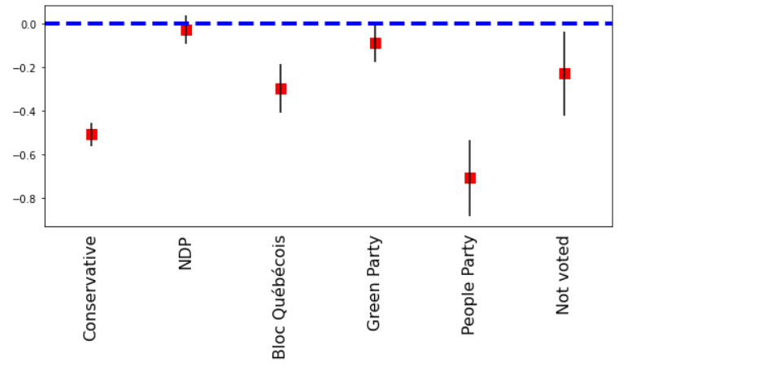

Figure : Voting behavior coefficient (Reference group=Liberal Party)

**Appendix**

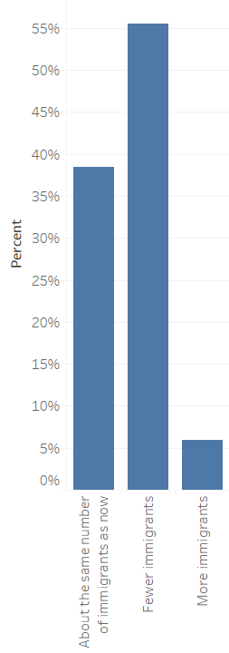

Figure : The distribution of dependent varibale in data

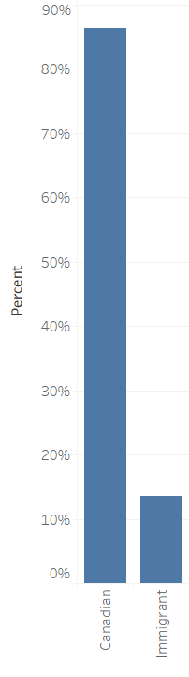

Figure : The distribution of Native variable in the data

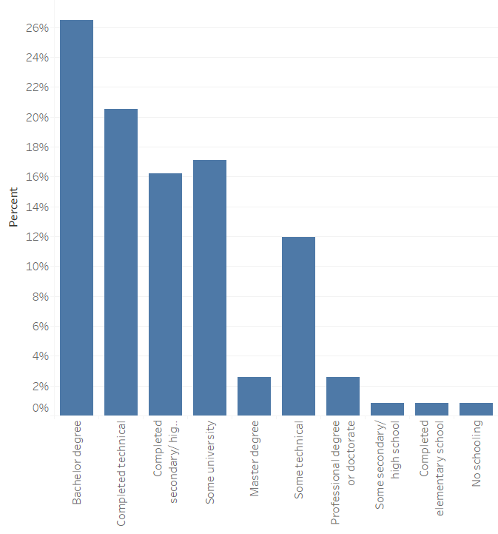

Figure : The distribution of Education level variable in the data

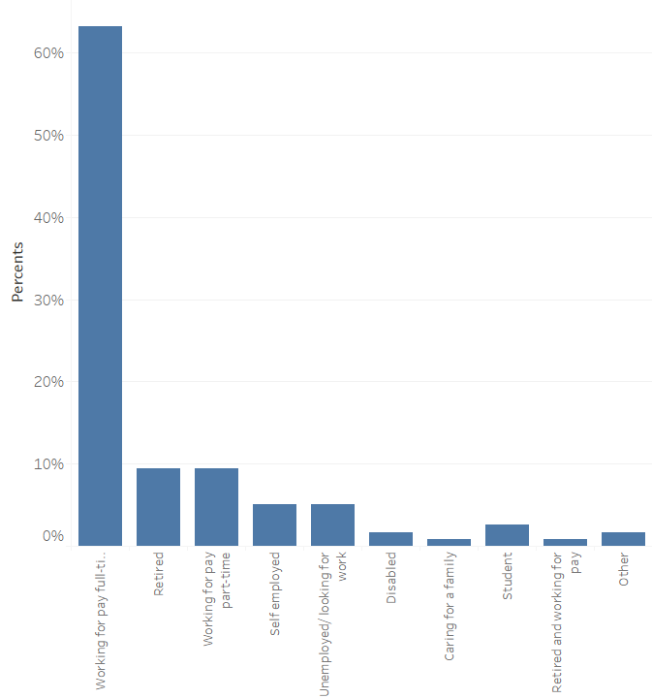

Figure : The distribution of employment status in the data

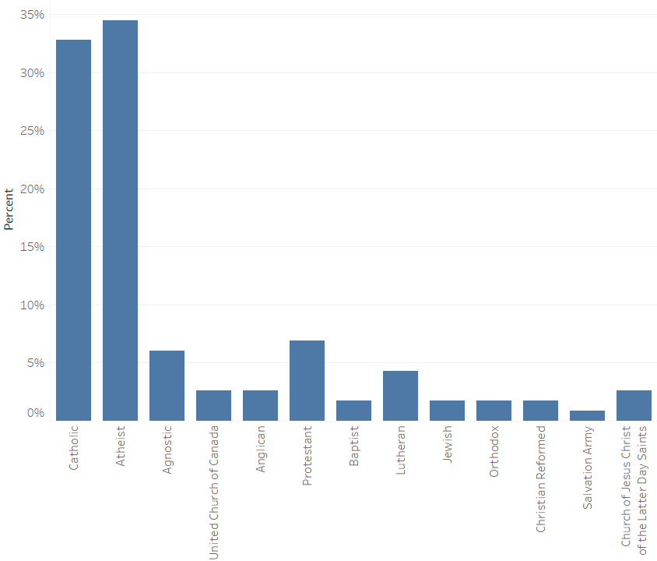

Figure : The distribution of Religion variable in the data

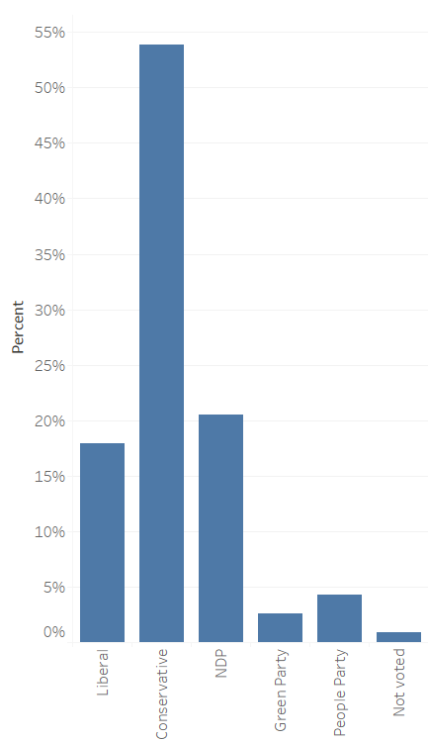

Figure : the distribution of Vote choice variable in the data

**Bibliography**

Bilodeau, Antoine, and Mebs Kanji. 2010. “The New Immigrant Voter, 1965-2004: The Emergence of a New Liberal Partisan?” In *Voting Habits in Canada*, 65–85.

Campbell, Angus, Philip E Converse, Warren E Miller, and Donald E Stokes. n.d. *THE AMERICAN*.

Fortin, Jessica, and Pj Loewen. 2004. “Prejudice and Asymmetrical Opinion Structures: Public Opinion toward Immigration in Canada.” *Annual Meeting of the Canadian Political …*, no. August. https://www.cpsa-acsp.ca/papers-2004/Loewen-Fortin.pdf.

Gidengil, Elisabeth, André Blais, Richard Nadeau, and Neil Nevitte. 1999. “Making Sense of Regional Voting in the 1997 Canadian Federal Election: Liberal and Reform Support Outside Quebec.” *Canadian Journal of Political Science* 32 (2): 247–72. https://doi.org/10.1017/S0008423900010489.

“Government of Canada.” Canada.ca. / Gouvernement du Canada, October 30, 2020. https://www.canada.ca/en/immigration-refugees-citizenship/news/notices/supplementary-immigration-levels-2021-2023.html.

Gravelle, Timothy B. 2018. “Partisanship, Local Context, Group Threat, and Canadian Attitudes towards Immigration and Refugee Policy.” *Migration Studies* 6 (3): 448–67. https://doi.org/10.1093/migration/mnx058.

Hainmueller, Jens, and Michael J. Hiscox. 2007. “Educated Preferences: Explaining Attitudes toward Immigration in Europe.” *International Organization* 61 (2): 399–442. https://doi.org/10.1017/S0020818307070142.

Hainmueller, Jens, and Daniel J. Hopkins. 2014. “Public Attitudes Toward Immigration.” *Annual Review of Political Science* 17 (1): 225–49. https://doi.org/10.1146/annurev-polisci-102512-194818.

Hanson, Gordon, Kenneth Scheve, and Matthew Slaughter. 2005. “Public Finance and Individual Preferences over Globalization Strategies.” Cambridge, MA. https://doi.org/10.3386/w11028.

Harell, Allison, Stuart Soroka, Shanto Iyengar, and Nicholas Valentino. 2012. “The Impact of Economic and Cultural Cues on Support for Immigration in Canada and the United States.” In *Canadian Journal of Political Science*, 45:499–530. https://doi.org/10.1017/S0008423912000698.

“Immigration: Reducing Overall Levels and Prioritizing Skilled Immigrants.” People's Party of Canada. Accessed December 7, 2020. https://www.peoplespartyofcanada.ca/immigration_reducing_overall_levels_and_prioritizing_skilled_immigrants.

Javdani, Mohsen. 2020. “Public Attitudes toward Immigration—Determinants and Unknowns.” *IZA World of Labor*. https://doi.org/10.15185/izawol.473.

Quillian, Lincoln. 1995. “Prejudice as a Response to Perceived Group Threat: Population Composition and Anti-Immigrant and Racial Prejudice in Europe.” *Source: American Sociological Review*. Vol. 60.

Rustenbach, Elisa. 2010. “Sources of Negative Attitudes toward Immigrants in Europe: A Multi-Level Analysis.” *International Migration Review* 44 (1): 53–77. https://doi.org/10.1111/j.1747-7379.2009.00798.x.

Scheve, Kenneth F., and Matthew J. Slaughter. 2001. “Labor Market Competition and Individual Preferences over Immigration Policy.” *Review of Economics and Statistics* 83 (1): 133–45. https://doi.org/10.1162/003465301750160108.

Sidanius, Jim, and Felicia Pratto. 1999. *Social Dominance*. *Social Dominance*. Cambridge University Press. https://doi.org/10.1017/cbo9781139175043.

White, Stephen, and Neil Nevitte. 2013. “Native-Born and Foreign-Born Attitudes towards Receptivity and Conformity: The Dynamics of Opinion Change in Canada.” *Immigration and Public Opinion in Liberal Democracies*, 307–34. https://doi.org/10.4324/9780203095133.